Configuring VLANs and Trunking

Overview
VLANs have historically been used to segregate traffic within a single network segment. In a VLAN scenario, computers with switch connectivity are configured with different network addresses. For example, Sales computers might be on the 192.168.4.0/24 network, while Marketing might be on the 192.168.5.0 network. When placed on the proper VLAN port, Sales computers will only be able to communicate with other Sales computers and Marketing computers will only be able to communicate with other Marketing computers. This project is designed for you to explore this concept.

This project uses a starting template for Packet Tracer (Configuring_VLANs_and_Trunking_Student_Project.pkt). The switches in this project have only basic default configurations. This project is designed to be completed in less than an hour.

Outcomes
- In this project, you will successfully configure VLANs to include VLAN name and IPv4 addressing. You will then use VLAN Trunking Protocol (VTP) to distribute the VLANs to the switches.
- You will discover how to manage inter-VLAN switching using Trunking.
- You will also learn and demonstrate how STP is used to provide resiliency in links.

Scenario

The Ogden location segregated their different departments using on-premise routers. You have been asked to go to Provo and set up the Sales, Marketing, and Administration networks. The Provo office works as teams with a representative from each department in each office. The respective department computers need to communicate with the same department computers on the other teams. You are out of routers, so you need to accomplish this task using existing switches.

When you arrive, you find there are 3 team rooms, each with 3 workstations. There is a 24-port Cisco 2960 switch in each room. The Sales PCs are patched into fa0/1 on each switch. The Marketing PCs are patched into fa0/5 and the Admin PCs are patched into fa0/9. IP addresses have been configured on each PC on the 192.168.1.0/24 network. The switches have no VLAN configurations. All PC’s can ping all other PCs.

Here are your tasks for this project:
- Configure all the computers for internetwork communication.
- Configure VLANs for the respective departments.
- Configure Trunking to only allow the created VLANs.
- Configure resilient links and explore STP

Here is the logical topology:

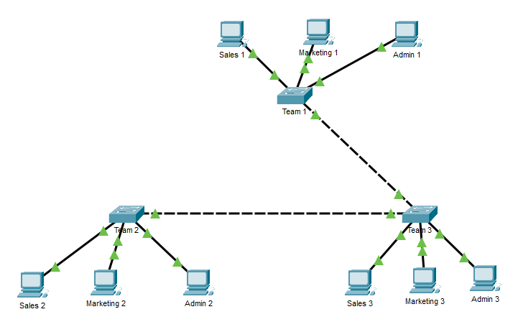

Instructions
- Open the following file:
  - Configuring_VLANs_and_Trunking_Student_Project.pkt
- Rename the file as follows:
  - fLast_Configuring_VLANs_and_Trunking_Student_Project.pkt
  - For example, if your name were Bob Smith, you would name the file as follows: bSmith_Configuring_VLANs_and_Trunking_Student_Project.pkt
- Carefully review the Notes section before continuing.
- Open the Configuring VLANs and Trunking - Worksheet.docx. Use the worksheet to document your project
- Save the worksheet.
- When done, submit your Packet Tracer file and completed worksheet through the submission link.

Notes
- The focus on this project is configuring VLANs on the switches and configuring Access and Trunk ports. You will also introduce a redundant connection between the switches and explore how to configure EtherChannel. You will also see how STP prevents switching loops.
- There are no routers used in this project. When you configure computers, you will not need a gateway.
- No configuration has been done on the switches. It is up to you to configure the hostname on each switch. You are welcome to configure additional items, if desired.
- Switch interfaces are all on, by default. In normal practice, you would shut down unneeded switchports for security, but you won’t need to worry about it for this project.
- All PCs have been cabled and addresses on the 192.168.1.0/24 network. Connectivity has already been tested.
- STP has been disabled on the switches. There is no link between the Team 2 and Team 1 switches to prevent a switching loop.
- Pay close attention to the project worksheet as it is designed as a teaching as well as an assessment tool.

